UltimateAAC Help

Introduction

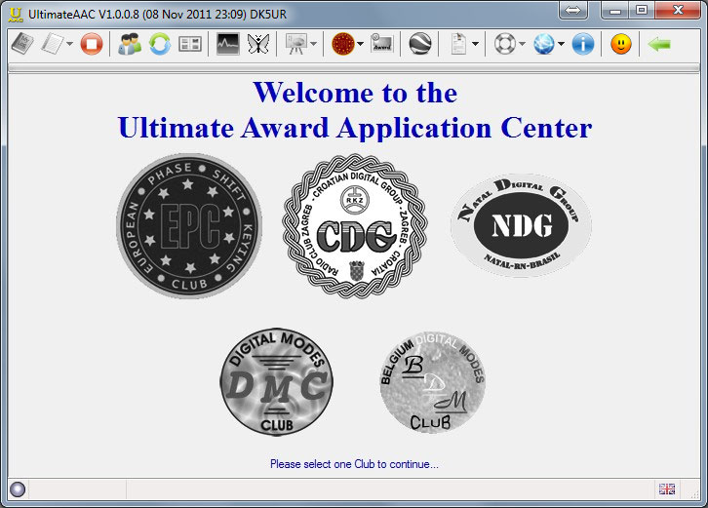

What is UltimateAAC ?
At the beginning there was fire...
Old-timers might remember the prototype of an award application: exhausting and time eating. One had to search through the entire logbook in order to compile Word documents, sign them and finally have them sent to Jurij.Wil's, DH5WB, Online-application was a great relief and simplified the whole process pretty much.He checked and evaluated the ADIF-files according to the EPC Award criteria and forwarded the results to the Manager.For that purpose I created MixW2EPC. It allowed the user to convert his MixW Log into ADIF-files that only contained EPC relevant data. An add-on for other logging programmes was included subsequently.I have developed parallel to Wil's online-application MixW2EPC until in July 2007 the first publicv version of UltimateEPC has been released. In the course of time, plenty of awards have been added together with a larger variety of logging programmes that allowed direct access. The result and the idea was to make the life of an EPC member an easier one.UltimateEPC is now the official way to apply for the awards of the EPC.In June 2011 UltimateEPC was again expanded, to meet the new functionality it was renamed to UltimateAAC. Now, the award programs of five digital mode clubs are evaluated.Linux and Mac users do not yet benefit form this development. None the less, they can send ME their files as ADIF. I will then make a check and will prepare the application process in their name.

...and in the future
Our future plan is to have UltimateAAC extended to other software systems as well as a growing diversity of awards.

Why asked the software for my personal datas?

This data is the same as the one being used for the membership application and is essential for creating the headlines with all personal information in the Award application. This personal data is also important in order to verify the EPC membership which is required for any Award application.Some of you might handle several different call signs. In order to have a better survey, it is possible to create separate categories for each call sign. Make sure to choose the correct call sign when applying for an Award.

What will do UltimateAAC with my log datas?

UltimateAAC can handle the following file formats: HRD5 (DSN), HRD4/DM780, DXbase2007, DXKeeper, SWISSLOG5 (*.mdb), MixW (DSN,*mdb,*log) and DigiPan (*.log), AirLinkExpress (*mdb) and Hamlog32 (*dbf) or ADIF. All other logbooks must be converted into ADIF. UltimateAAC will not do changes to the original log file. All QSOs done before 01. Jan 2000 will be automatically filtered out. The system will only accept QSOs in (BQ)PSK(31,63,125) and from 10. Jun 2006 EPC numbers as well as Areas (if known) will be added.In case of ADIF the following minimum requirement applies:, , , or and .additionally (if available): like JO41AA or JO41 like EU-111 and both consist of 1 to 2 digits and for the YLPA.In order to have the evaluation process working perfect, following Awards require special details in the field:YLPA: "#YL" or "#CSYL"GNOME: "#QRP"CRUMB: "#PWR 1-5"DXDA: additional "#DX 0000"DKPA: additional "#AREA XX.00.XX"With DigiPan IOTA as well as GRID references can be stored in the field. ("#IOTA EU-098 " or "#GRID JO40JI ").Any other format than this will be ignored by UltimateAAC.CQ and ITU zones are software generated or are taken over if already existing. For VK, UA, W, VE, PY and BY the software will use self-generated zones since these are most of the time more precise then the one coming from any log software.The completed data files are then send through the evaluation module and result in a final overview. Possible single results as well as errors might be displayed.

The Menu

Open Standard Logbook

Retrieve the Award status from the EPC-MC, reads your standard log (User data) and checks the log for awards.If still no standard logbook has been given, a dialog will be opened and prompts for the data.

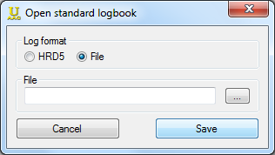

Select log format at first. File - For all mdb, log and adif files that allow direct access orHRD5 - for the new logbook access with ODBC (for 64-bit systems it's necessary to create the DSN in 32-bit ODBC manager)In case of File just push “…” and choose in the next dialog the file format and the log file. Confirm and save.In case of HRD5 the window changes to...
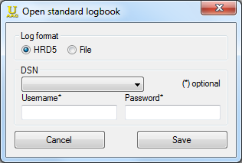

Now you must just select the correct connection settings (in the DSN frame). Username and password might be displayed automatically. Anyway, in some cases you might be asked to enter the correct password. (in most cases SQL-servers, rather than ACCESS-servers require the password) Finally just hit “SAVE” - That is it!

Open...

This menu item offers different choices of log formats.Just choose any of your log files for evaluation. This process runs without any further support. Please make sure that the selected log file corresponds with the chosen file format. *.mdb is not the same as *.mdb. The logfiles *.log have different fields, too.The Award status is harmonized by EPC-MC, the selected log is being opened and the the results are displayed.

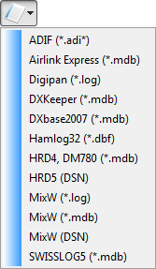

Exit

...closes UltimateAAC.

User datas

Please enter personal dates here.Start with the Call Sign.When moving to the next field Name as well as Email address will be retrieved and taken over from the EPC Data base in case of EPC membership. If necessary, update the dates or enter them here. Select the Format (pdf or jpg) in which the Awards shall be created. That applies very seldom anyway.The Manager Password is only of importance for the Award Managers!!The field all used call signs in this log is being used by the Award Manager to avoid the reply "Not in Log" by your QSO Partners in the event of a QSO validation request. Background: a QSO was done using e.g. a former call sign or a club station call sign.Therefore it is in your own interest to give information there. It's not necessary to insert your main call sign, xxx/P or xxx/QRP...

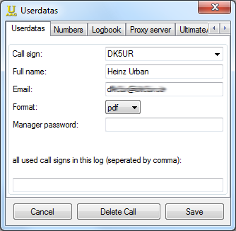

You will find all your membership numbers of the supported clubs in this window.One click to the Join button opens the homepage of the selected club to fill the membership form.New awards just a click away :-)

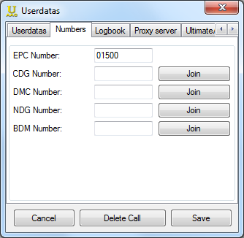

In the next step a standard logbook will be selected. Select either "open standard log" or "Open...". "Open standard log" selects logbooks with direct access to their data base. Access is provided with “SQL” through an existing DSN.The standard server is used to collect Award applications and to forward them to the Award Manager. Make sure to select one since the application procedure is going to fail otherwise.Username and password are only relevant when used with “SQL” and are depending on the security adjustments of your SQL server.
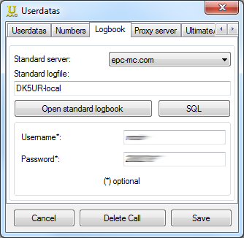

If you have a proxy connection to the internet, please set a check mark here and enter the Proxyservername and Port.If your Proxy asks a username, check mark “Proxy with authentication” and enter username and password.The connection is now being started via Proxy in windows. Consequently the dates have to coincide with the dates in “internet options” of Internet Explorer.

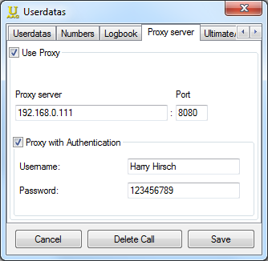

If Use USB Stick is check marked and any path has been selected, UltimateAAC will create copies into any required files within this very path. This does not touch the Registry and will not leave behind any marks in the Internet Café. There are plenty of good reasons to chose this mode!

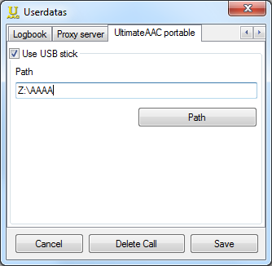

Now all basic and necessary adjustments have been completed. Now “SAVE” all!Should there are further EPC-Members in your family, not a problem!Just enter the additional call signs into the "Call Sign" field, add all further required details to the user data window and “SAVE”. It is that easy! But pay attention when checking for results:Make sure to select the correct call sign. (You will find it in the window tile)To switch to another call sign just select the call sign from the drop down box and “SAVE”.Any datas and Award info is being administered separately.What is left? “DELETE CALL SIGN”This transaction deletes all dates and Award Info, irretrievably!!!

Update

New members database are loaded from the Internet and updates UltimateAAC, possibly also draws attention to new software versions, which can then be downloaded.Must I update?No, but the EPC is growing daily by an average of ten members. But every member counts for various awards more points than a non-member. Only with the latest member list, you can really score. That is the reason why UltimateAAC asks every three days, whether it is intended to update members' records. It is wise to affirm this, but that's up to everyone himself :-).

My Awards

Opens the personal award statistics. Been here one can see what awards have been worked, applied for or have been already received. 100% received award series will be outsourced in a second window. This is accessible via the button "100% Awards."

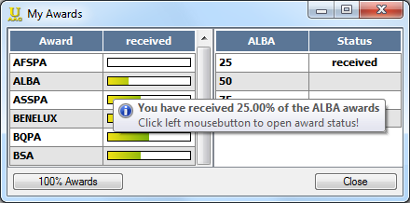

In the left table you will find the award series with percentage of already received diplomas. The right table shows the status of each individual award. If the right table is not visible, click left on the desired award series. The status is set automatically. A click with the left mouse button on a single award (eg on the CQPSK-10) leads one directly to the EPC-MC to download (in case of DMC it leads you direct to the DMC homepage), if the status is "received". In the case of "requested" there will be the possibility to apply for an unlock code, it allows one to apply for this award again.

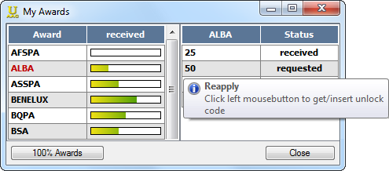

Alarm list for DM780

You can create alarm lists for DM780, as well as in DM780, the window was deliberately modeled on that of the DM780.

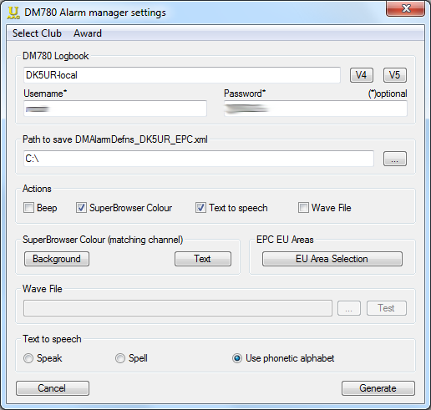

First, we selected the DM780 logbook. V4 for DM780/HRD4 and V5 for the new version 5Also here you will find the already known or required input options as described in "open standard log".Next, the location of the alarm list to be created has to been specified, the file name already was specified.The action and sound settings known from DM780, and the color design of the super-browsers are also available here.Additionally, you can still limit the alarm list for EU Areas.All this is true by default for the EPC members, of course, you can compile the list by other criteria, for example only for certain EPC Awards or for other Digital Mode Clubs . These member lists are updated in painstaking detail work by Laurie, VK3AMA.

icons.cfg for MixW

This window shows the paths to the MixW log and the location for the generated icons.cfg can be set.It should be noted that the icons.cfg is limited to max. 4950 lines, even a split on multiple cfg files does not improve. If this limit is exceeded MixW crashes!The generated cfg file contains only the EPC members that have not been worked, nothing else. If you want to have more like flags or similar icons in MixW, it is advisable not to choose the installation path of MixW as the location, because the icons.cfg is overwritten without any comment.

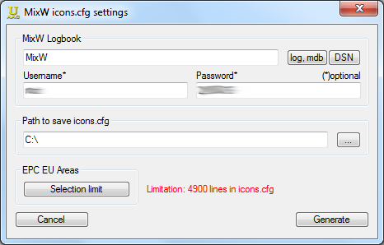

With "Selection limit", the result can be defined more precisely by highlighting the desired EU Areas. Multiple selection is possible.

Statistics

First, select which stations should be considered (SWL, amateur radio station or all).Then opens a selection window in which the number of members per continent is represented. Has been previously evaluated the log, the first number before the slash is the total number of members and the second number representing the number of worked members. Without the prior log analysis the second number falls away.

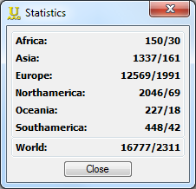

By clicking on a continent, or even the world, comes to an output window where the members be broken down to DXCCs .

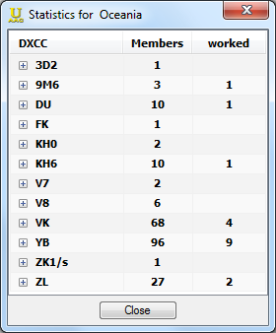

With a double click on the DXCC or click on the cross one gets to a detail view.

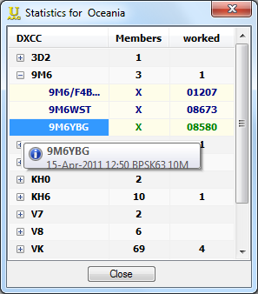

Here you can see all the members of the selected DXCCs. If a log analysis was performed before, not worked Members displayed in blue, already worked in green. The QSO details can be made visible by clicking on the callsign. In the case of Europeans will be displayed even the EU area.

Toogle between EPC, CDG, BDM, DMC and NDG awards

This switch UltimateAAC to the EPC, BDM, CDG, DMC or NDG mode. The logs are then evaluated according to the rules of the selected clubs, EPC is standardly chosen. EPC members can also purchase the certificates of the other clubs free of charge. Deliveries are made as well as for the EPC, in the EPC-MC, with the exception of the DMC.The Croatian Digital Group is represented since 01 January 2009 in UltimateAAC, the Natal Digital Group from Brazil since September 2009 and the BDM and DMC are since June 2011 with the bunch.OMs and YLs can join all the organizations from around the world.

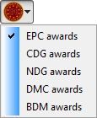

exclude Awards

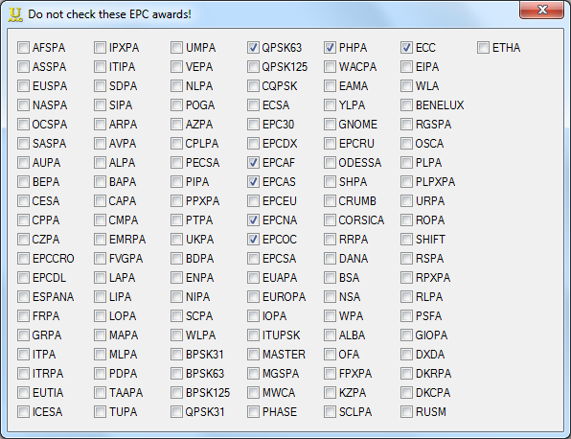

In this window you can select the awards that are not to be evaluated during the log analysis. This brings a noticeable speed increase in log analysis. It makes sense to choose only the diplomas, which have worked to 100% :-)

GoogleEarth

Appears only if GoogleEarth is installed and only in EPC mode.

= OM

= EPC Club Station

= YL

Save/Restore all personal datas...

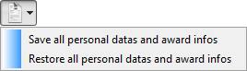

Save all personal datas and award infosThe entire UltimateAAC key from the registry is stored to a reg file, which can be played back in worst case. For this purpose, the file must be stored on one extrenal storage medium, otherwise it is lost in a hard drive crash,too ...Restore all personal datas and award information A previously saved reg file is inserted into the registry, and thus restore the data.

Manager

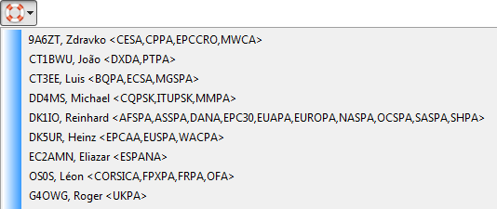

Here you will find all the award manager of the currently selected clubs with awards for which they are responsible.All are clickable links that open your default email program so that immediately an email with questions, etc. can be sent to the selected manager. Please select the RIGHT manager for questions to awards.

Links

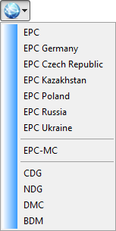

Some links to other websites and EPC.

About

Short thank you to all suppliers of ideas, volunteers and donorsEven here again:thousand times THANK YOU

Donate for UltimateAAC

Who wants and who like the program, must here express his joy expressedBut all voluntary - as the name suggests :-)

Synchronize UltimateAAC portable -> UltimateAAC

Appears only when running UltimateAAC in portable mode.

Without further prompting, the personal data and information obtained from the portable computer directory will be entered into the registry. Thus, the changes that have emerged during portable operation were synchronized with the main program.

The Mainscreen

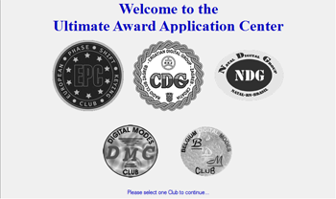

The start screen ...Here you see all the digital mode clubs for their award program your logbook can be evaluated with the help of UltimateAAC.In order proceed simply select a club.

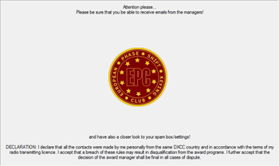

.. now it gets down to business ...This is the start screen of the selected clubs. The menu icons are now active, as far as they are relevant to the club.At the bottom of the screen is the explanation about the accuracy of the data in your log.This is acknowledged by use of the program.ONLY FOR EPCNeither Heinz (DK5UR) nor Yuri (MM0DFV) have influence on the decisions of other managers or influence them, it makes no sense to contact us with complaints.

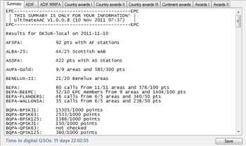

... after the log analysisThere appear a bunch of tabs. Always present are "Overview" and "ADIF", the others depend on your activity.Also an "error log" tab can appear, but more on that later.

Summary

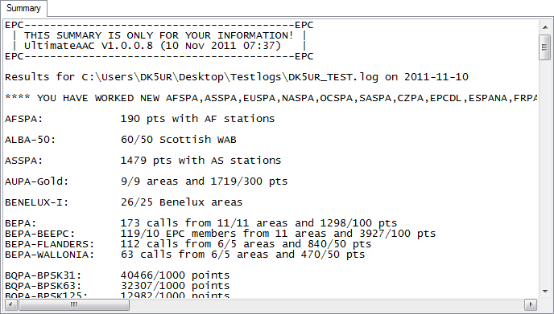

An overview of all awards and award classes and the total points are shown in a table.Should new awards have been worked, the statement "You have worked new awards XXX" is displayed. So you can easily jump to the appropriate award tabs to apply for them.Left below the summary indicates a small QSO Time text, which shows you how long you've been sitting in front of the PC around the QSOing.Right below the summary is a Save button, with this you can store the summary to a text file.

ADIF

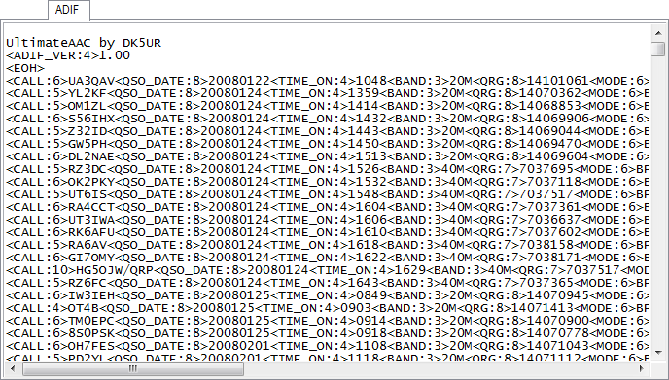

This tab shows all of the evaluable QSOs for EPC awards in ADIF format. Actually, it's obsolete because the online application has been set, but for one or the other, this possibility is perhaps even more useful. The data can be stored as ADIF file with the Save button at any location.

ADIF MMPA

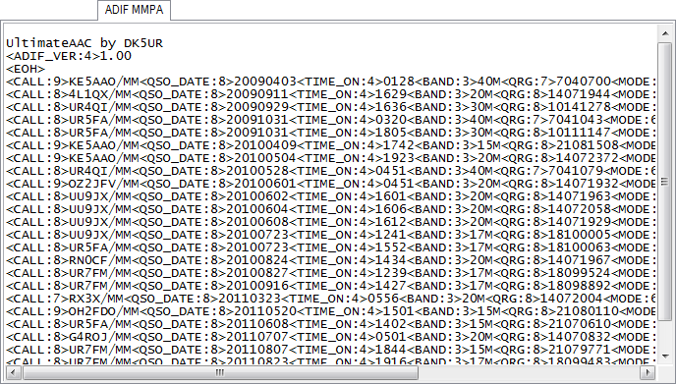

The available QSO data can be adapted for the MMPA application. For maritime mobile stations UltimateAAC can not calculate ITU-zones (if anyone has a useful approach, I'm open for all ideas :-)), you have to do this work yourselves. ITU zones can only be determined using the GRID locator. This is a good help for example DXAtlas.When more than ten /MM are in your log a Check button is displayed below the result. UltimateAAC counts the different ITU zones and displays a corresponding sessage. If the award requirements are met, the application may be sent if not there is a possibility to change the zones in the window directly. After that you can use the Check button again, and so on. Is everything in order and have been worked sufficiently ITU zones the Check button changes into a Apply button, and then everything else will proceed as usual.

EPCAA tab (SWLs only)

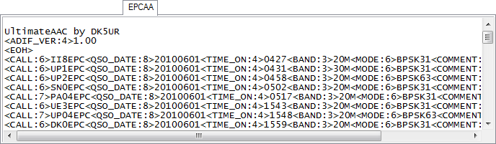

This tab appears only for SWLs to give them the possibility to participate in the EPCAA award program.Therefore it is necessary to log the worked station of the EPC club station in the COMMENT field of the logging program. In order to identify these calls clearly it's necessary to mark them with "#WRKD", eg "#WRKD DK5UR". The result should be stored for an upload in the EPC members center.UltimateAAC evaluates only connections with EPC club station in the month of June for a leaner file.

ETHA tab (SWLs only)

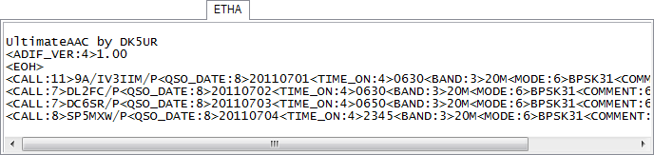

This tab appears only for SWLs to give them the possibility to participate in the ETHA award program.Therefore it is necessary to log the worked station of the ETPA activator in the COMMENT field of the logging program. In order to identify these calls clearly it's necessary to mark them with "#WRKD", eg "#WRKD DK5UR". The result should be stored for an upload in the EPC members center.UltimateAAC evaluates only connections with portable station since July 1th, 2011.

Award tabs

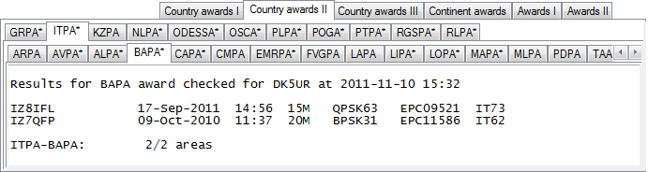

The different award tabs are all created equal. Among country awards will find all the awards for which only contacts with certain EU areas or DXCC count. At the continental awards one find the awards for the connections be considered with the different continents. And finally the Awards I to III, here are all the diplomas to be found that do not fit into the previous categories.Some awards are subdivided for clarity. Each tab has its own Apply button. The button always appears right below the award result, but only if the awards requirements are met. This is obvious to one in the overview and the other to the tabs themselves. A award is met, the tab marked with an asterisk, so you can see quite quickly where action is needed.Left below the result, we find the Award Rules button. It calls the current award rules and is thus a good starting point if you badger yourself with questions like "Why XX9AA is not shown in the PHASE analysis, though I have worked in BPSK63?"The MGSPA has another special feature. You can find here the DXAtlas GRIDS button. You can save all worked grid squares to a *.wkd file to be read or displayed in the DXAtlas .

Error-Log

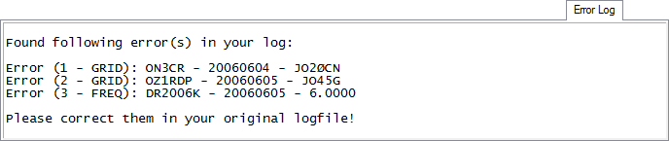

This tab identifies all the "errors" in your log.In the first error you see a numerical fault Ø is not equal to zero.In the second case the locator is too short.In the third case, the frequency is false.Sometimes the errors are not immediately apparent:- a comma instead of a point- a space where none belongs- a letter too much or too little...This error log can be saved, too. You can correct later the problem cases.

The Statusbar

(Click to the status bar fields to learn more)

Check awards in EPC-MC to activate the apply buttons

Awards are not yet verified -> Application is not possible

Verification is running

Verification is completed, no new awards available in the EPC-MC

Verification is completed, new awards available in the EPC-MC

Problem in verifying -> Application is not possible

Program Infos

Information on the ongoing evaluation are displayed here so that you know where you stand :-).After the evaluation appears here where appropriate a notice of the application date of the award.

Select Language

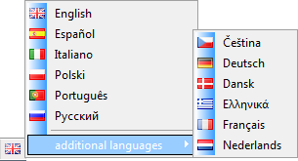

Left click on the flag in the status bar allows you to change the language of UltimateAAC. You will see a selection of installed, as well as other available languages. If you select an already installed language, UltimateAAC is immediately translated into that language. If the desired language is not installed, just click on "additional languages ". The language file will be downloaded and set as the default language, if that is desired.

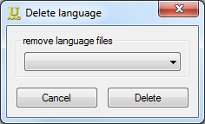

A right-click on the flag in the status bar opens this window.You can choose from a list of all installed languages , all languages can be deleted, except English and the default language of the user.

Change size

As usual you can click and resize the window.The only known problem:If you minimize to the taskbar or resize the window while evaluation the log, the presentation of results will be destroyed.

The Award Application

The result of the evaluation of awards is dependent on the actuality of the data set, this is usually updated daily. A click on the "Update" button BEFORE the log check is not a bad idea, if you want to reach all possible points.All awards will be applied directly at the manager.For questions regarding the whereabouts of awards is the manager the only right person!The way to application...is always the same...Member database update, if not doneLog check ("Open standard log" or "Open...")when the "Apply" button appears, click the button at existing Internet connection the evaluation will be sent automatically to the manager, Done...Sent automatically?UltimateAAC try to forward the award application to three different servers. If it works not with the first server, it's addressed to the second, etc. It is therefore highly probable that the award application reaches its recipient.Now it is practice in patience. After one day you can check the EPC-MC to see if the award is issued, or you query the award status in UltimateAAC.But always remember:all award manager work voluntarilythey all have a job, they need to pursuethey all have social obligations. Yes, the family wants to see every now and then her husband/father/sonor sometimes they are even on vacation...After a week still no news?If you haven't heard anything after a week, simply have a look into the appropriate award holder list. Above right is the date of last update, is it younger than the award application date and your own call sign does not appear in the list, it is quite possible that the application unexpectedly landed in data nirvana of the internet, but that happens very rarely. Then usually there are some missing answers to the random checks of the QSO data.If the date of the list is older than the application there is no reason for concern, then everything is still in flux.After two weeks, still no news?UltimateAAC now gives you the chance to make a second application. And the waiting begins anew. (see above)After four weeks, still no news?UltimateAAC again gives the opportunity to reapply for the award, , but also noted that it is probably time to sit down with the manager.So there is no reason to fiddle unnecessarily in the Windows Registry or in the UltimateAAC.xml for an earlier reapply, which speeds up anything or anyone, quite the opposite.It's more than very unpleasant, if a manager receives five or more applications per day for the same award, because after 12 hours the award is still not available for download.

